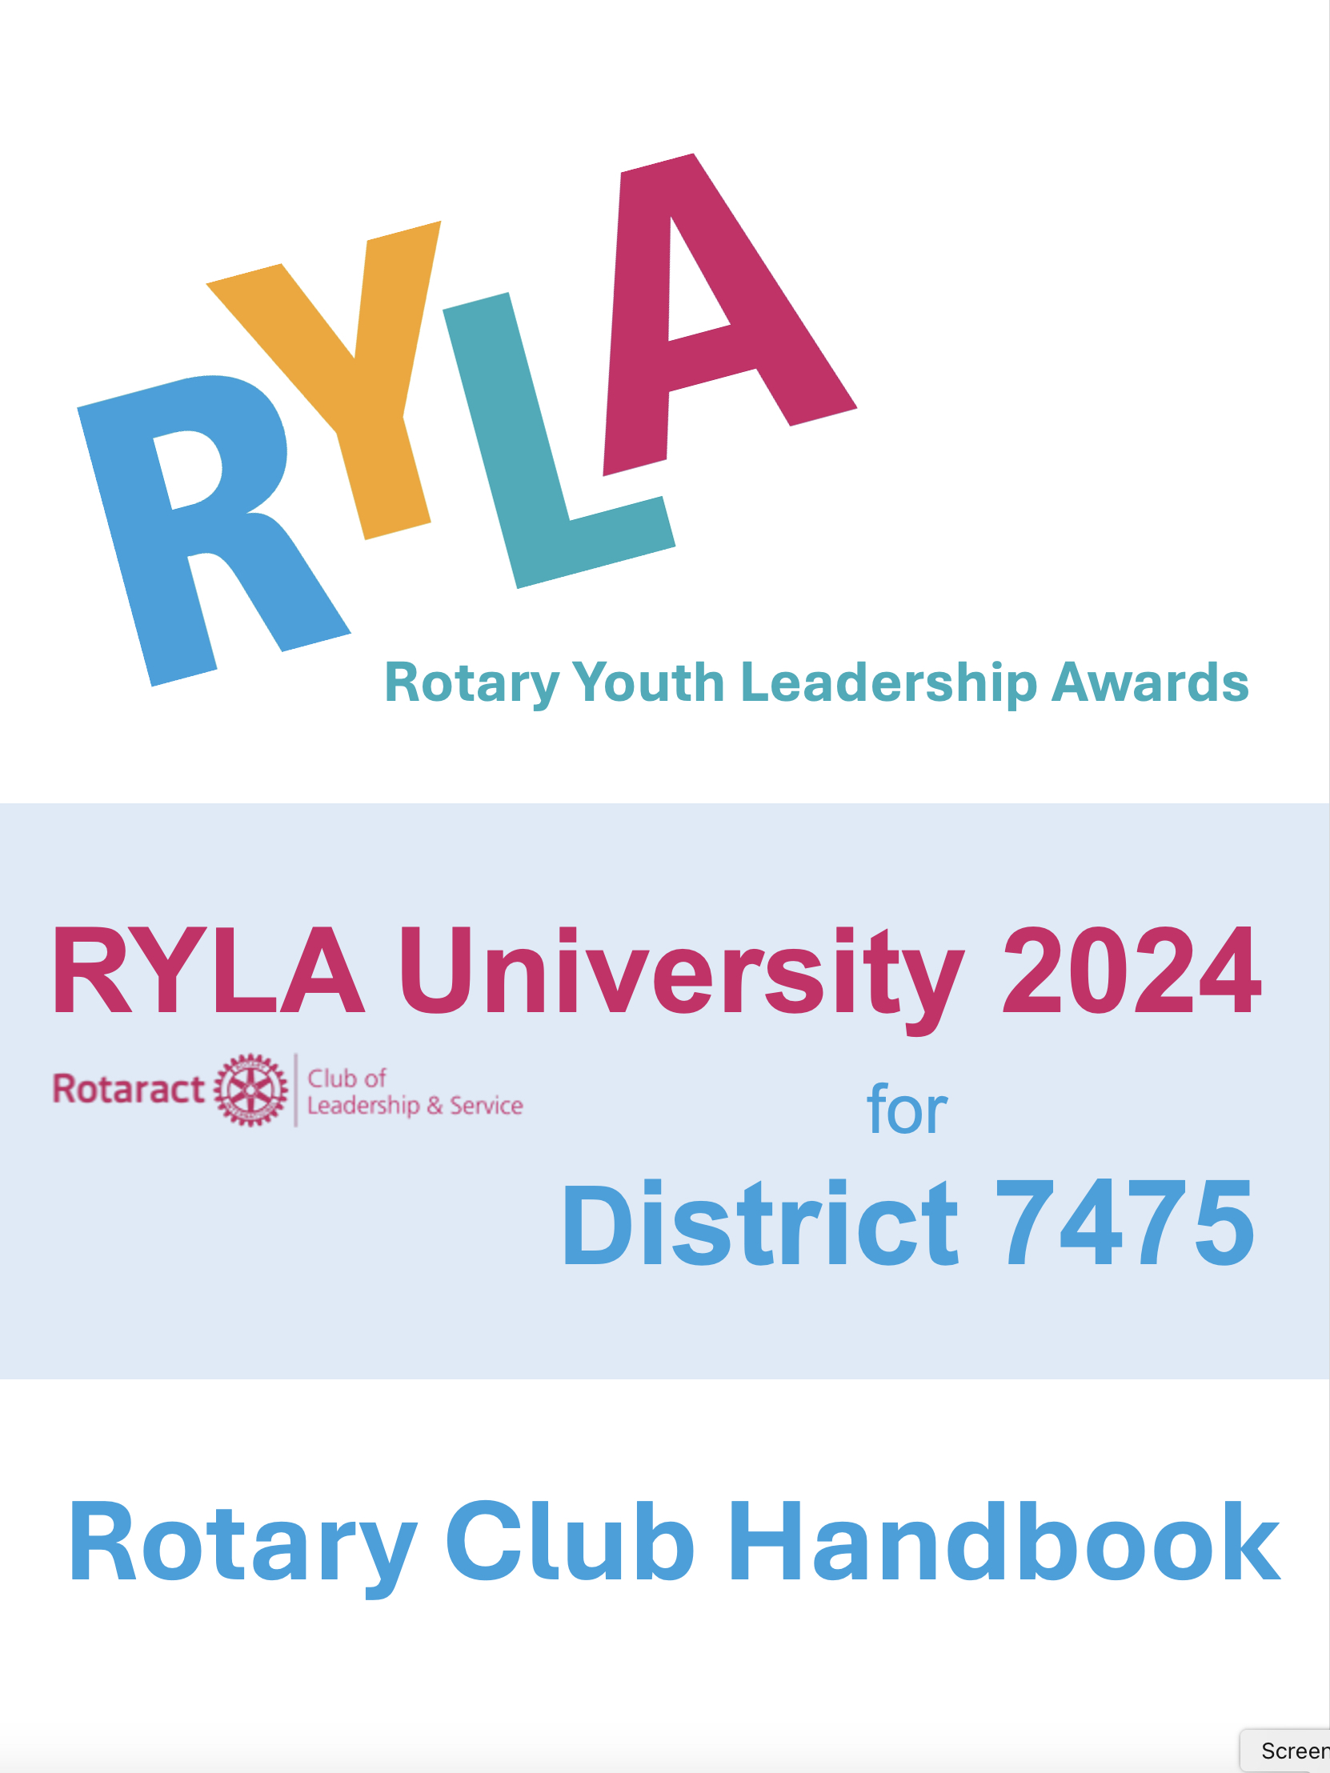
General Details

WHAT: RYLA University 2024
WHO: Prospective attendees should be high-school students who will ﬁnish their junior year this June. RYLA regulations require that attendees must be under 18 for the duration of the conference.
Successful candidates will be students who have excellence in character and scholarship and have demonstrated a desire to lead. The program is gender neutral and can accommodate special needs.
WHEN: Sunday, June 30 – Wednesday, July 3, 2024
* Selected participants must be in attendance for the entirety of the conference. They are not permitted to arrive late or leave early. (Circumstances of health, family emergency or other will be handled on a case-by-case basis)

WHERE: Drew University
36 Madison Avenue, Madison, New Jersey 07940 https://drew.edu

COST: The cost of the 4-day, 3-night RYLA program is $500 per student. This includes room, food, program supplies and RYLA swag.

If paid before May 1 there is a $25 early-bird discount ($475 per student). You can reserve and pay for space before you have a student(s) selected.
REGISTRATION DEADLINE: All Registration Forms and payments must be received by May 15, 2024
Information & Links: All information and links to registration can be found on the District Website.
Direct Link: https://njrotary.org/ryla

RYLA Participant Registration

The following steps will allow your club to register a student for RYLA University 2024. Once registered, we will contact the student directly so they can fill out the application information required. Your club must register the student first. That is what starts the process.

  - Fill out the online Participant Registration Form. The link to the form can be found at https://njrotary.org/ryla
  - Write out a check to “Rotary District 7475” for the correct amount of scholarship funds. Note “RYLA 2024” on the check.
    - Early Bird Special pricing of $475 per scholarship paid by April 30
    - Regular registration pricing of $500 per scholarship beginning May 1
    - You can prepay to take advantage of the Early Bird Pricing. Send the check per #3 below and register the student(s) later after to have the names.
    - Because of the advanced payments and preparation required, scholarships are non-refundable. They can be transferred to another qualified candidate.
    - We encourage each club to name an alternate candidate as backup in the event the first candidate cannot attend for any reason. Identify these candidates as Alternates on the registration form.
  - Mail the check to our District Treasurer. Scholarships must be paid in full before participants will be confirmed.
Judith Frank
17 Condit Street
Succasunna, NJ 07876

Registration closes May 15

Helpful Information

- Do not Google RYLA to find information. Other district programs will be different. Get your information from our website or www.RYLAUniversity.com.

- Reach out to the high schools your Rotary Club represents. Explain what RYLA is (the RYLA Team can help with this if needed!) and discuss your intended process for selecting high-quality high school juniors to attend RYLA this year.

- Recruit your candidate(s) by coordinating and accomplishing the interview process with your high-school representatives/partners.
- Please use the interview questions in this handbook to assist with your selection process.
- Applying to attend RYLA may be a competitive process, as candidates will be awarded with a scholarship from your club to participate in the program.

- RYLA will be the most-rewarding experience for all if the participants are of diverse backgrounds, genders, and race. We strive for everyone participating in the program each year. Please select those who you believe to be the most-qualiﬁed candidates while also keeping this in mind.
- Contact and congratulate the participant(s) that your club has selected and inform them that they have been selected to participate in RYLA. Make sure they understand the investment your club is making in them and express the confidence you have that they will represent your club, community, and school accordingly.
- Keep your alternate candidates engaged just in case. It may be that another club’s candidate drops out opening up an opportunity in which case that club would pay for your alternate.

Follow Up Items

- As the program start approaches, please check in with selected participants to conﬁrm that they are attending and that they have completed their participant registration forms online.

- RYLA University check-in is Sunday June 30 from 9 AM to 10 PM. The program ends on Wednesday July 3 at 5 PM. There will be a closing ceremony prior to 5 PM that parents can attend. We will send details as we get closer to the date. Be sure the student understands that once they commit to being a participant, they are committed to attending the entire program without interruption and may not arrive late or leave early except in an emergency.

- All RYLA participants will be responsible for their own transportation to the camp via parent/guardian. Participants will not be permitted to drive to/from RYLA themselves or park a personal vehicle at the Drew University.

- In the extraordinary event that a participant needs to be sent home, the RYLA Rotarian Representative will be contacted as well as the participant’s parent(s)/guardian(s). If a parent/guardian cannot pick-up the participant, a youth-protection-certiﬁed member authorized person must be sent to take the participant to his/her home address on ﬁle.

Rotary International President Elect Gordon McInally said:
“I'm a great fan of RYLA. We have seen very successful RYLAs in our part of the world. If you take a high school student with potential to a RYLA experience, the change that can take place is amazing. Sometimes the quiet, introverted young students who go to a RYLA experience have, by the end of it, found themselves and are blossoming. It's important we send people with potential to the RYLA experience — not the highﬂiers, because they're going to ﬂy high anyway. It's the people we have the potential to develop.”

RYLA Candidate Selection Guidelines
- The applicants that your club will select should be high school juniors; 11th graders under the age of 18 before the end of the RYLA conference.

- The partnering high school should present your Rotary Club with two or three times the number of qualiﬁed candidates than you plan to select. Your committee should then interview and select the most qualiﬁed applicants to represent that school and your club.

- The following considerations are offered as criteria to be used in your selection process. Consider the applicant that is not consistently chosen for everything at school, but the one who deserves it:

  - Leadership potential - qualities that might make him/her an effective leader in the community.
  - Leadership experience - has the applicant had opportunities to practice leadership skills in real life situations? (Look for ofﬁcers of school organizations, athletic team participants, and extracurricular leadership experience).
  - Extracurricular activities - emphasize quality of involvement rather than quantity. Has he/she participated in any community activities? Does he/she have a job after school, evenings, or weekends?
  - Ability to be curious - does the applicant think about things that he/she reads or hears, or does he/she accept things blindly?
  - Articulation - is the applicant capable of expressing thoughts and feelings accurately, clearly, and effectively?
  - Ability to relate and interact with peers - how well does the applicant get along with others and adapt to social situations?
  - Openness to the participant experience - will the applicant be open and adaptive; will he/she embrace the philosophy of the RYLA Program?

- We recommend selecting multiple alternate candidates who will be prepared to attend the conference in the event that any of your primary candidates cannot. Last minute cancellations and the problems that they cause could be eliminated with the selection of pre-qualiﬁed alternates.

- We are looking for interested, sincere, well-rounded potential leaders. The selection of good participants is the critical element in the success of the RYLA program.

RYLA Candidate Interview Form

Form may be used by Rotarians conducting a live interview to record responses during conversation or may be given to candidates to ﬁll out and submit to Rotarians as an application for consideration for participation in RYLA. Candidate information will be important to know when registering participants for RYLA. All other questions are provided as guidance of what to ask when interviewing and selecting candidates for RYLA.

Candidate Information:
Name of Sponsoring Rotary Club:
Candidate’s First and Last Name:
Candidate’s Primary Email Address (NOT school email): Candidate’s High School:
Parent/Guardian Name(s)v and Phone Numbers (home and mobile):
Parent/Guardian Primary Email Address
Interact Advisor’s Name and Email Address (if applicable):

Questions:
Why should you be selected for RYLA?

How do you see yourself as a member of your community? (ex. setting examples, community service)?

Which clubs and activities are you currently active in in school?

Which activities are you involved in outside of school?

What are some leadership/team experiences you have had?

What would your friends say is your best asset?

Describe a time you were unsuccessful with a task and how you dealt with it.

Statement on COVID-19 Policy
RYLA 7475 adheres to the most-current New Jersey Department of Health guidelines and requirements. Consistent with Rotary as an organization that encourages and uses vaccines, we suggest all participants involved in RYLA get vaccinated against the
COVID-19 virus. RYLA 7475 will not require vaccination, though it is recommended. RYLA 7475 will not require participants to test for the virus prior to attending RYLA, though it is recommended.
RYLA 7475 respects everyone’s individual decision on whether to wear a mask at the program and ensure their comfortability in doing so.
RYLA 7475 reserves the right to quarantine anyone who does test positive or contracts COVID-19 during the RYLA program. If someone is known to have the virus prior to the program starting, he or she will not be allowed to participate—this goes for both participants and volunteers. RYLA 7475 reserves the right to dismiss participants from the program if the program staff determine a participant’s health status is a risk to others at the program.
This policy is subject to change depending on the health requirements, guidelines, and suggestions of the Center for Disease Control and Prevention (CDC) and/or New Jersey Department of Health.

Rotary Youth Protection
RYLA University, The Rotaract Club of Leadership & Service, Rotary 7475 and its staff adhere to the Rotary Youth Protection Guidelines:
https://my.rotary.org/en/learning-reference/learn-topic/youth-protection

Statement of Conduct for Working With Youth
Rotary International strives to create and maintain a safe environment for all youth who participate in Rotary activities. To the best of their ability, Rotary members, their partners, and other volunteers must safeguard the children and young people with whom they come into contact and protect them from physical, sexual, and psychological abuse.

It is your responsibility to familiarize yourself with the District’s Rotary Youth Protection Policy. The policy is available on www.njrotary.org by clicking on “Youth Protection” under Youth Programs in the main banner menu.
Rotarians or other non-Rotarian volunteers that will transport RYLA participants or otherwise may have unsupervised one-on-one contact with participants are required to complete Rotary International youth protection courses and undergo a background check.
RYLA 7475 follows the “Rule of Three,” meaning that one-on-one contact is avoided by having a minimum of three people together on any occasion.
Questions may be directed to Questions may be directed to District 7475 DGN Bob Law at bob.law.7475@gmail.com.

Ready to Rise! Ready to Rock! Ready to RYLA!
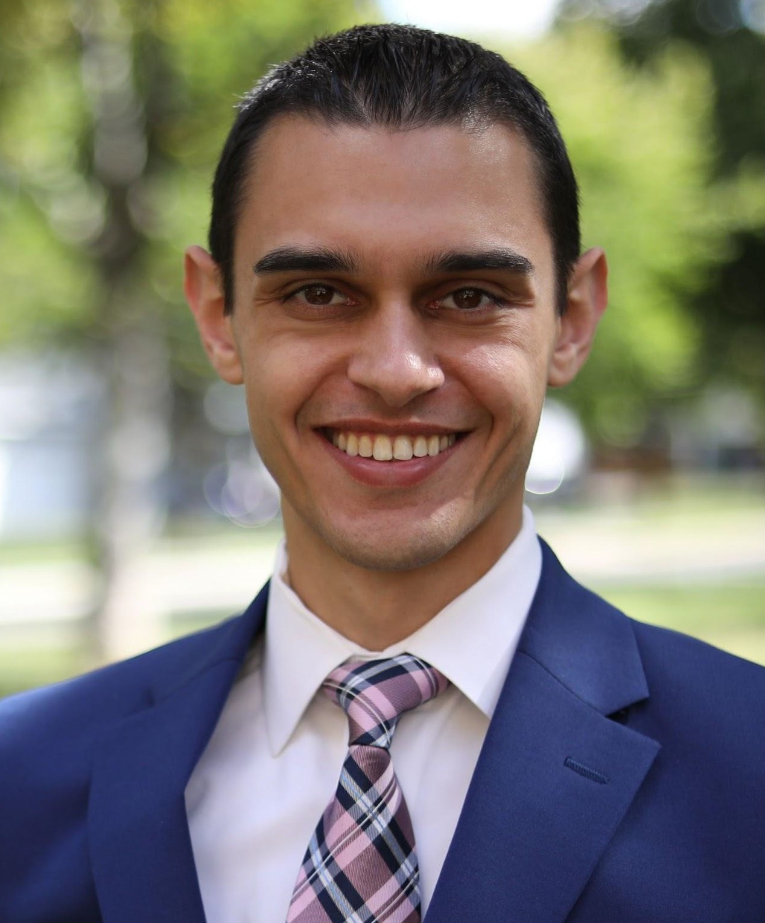
Rotaract Club of Leadership & Service President David Edelstein attended RYLA in 2014 as a representative from Paramus High School and the Paramus Rotary Club.
David’s ﬁrst involvement with Rotary was as a PHS student, volunteering at the annual Rotary Pasta Dinner held at the school. As a high school junior, David received the Certiﬁcate of Global Peace & Multicultural Understanding from the Paramus Rotary Club in recognition of his contest-winning poem on the topic of Multicultural Diversity. He was also a four-year scholarship recipient from the Paramus Rotary Club.
David describes RYLA as a program that had
immediate impact and lasting inﬂuence on who he is and, consequently, his entire life. While at RYLA in 2014, David learned lessons of personal, team, community and global leadership, teamwork and service. He immediately began putting these lessons to practice in his home, school and extracurricular life (including a heavy inﬂuence on a 10,000-word thesis he wrote as part of his black belt testing for Isshin-Ryu karate, titled “The Power of Words.”)
David reunited with RYLA in 2016, returning as a program organizer and leader. In 2018, 2023 and 2024, David visited RYLA 5330 in California to observe and share RYLA mindsets and strategies. This outreach continued as he connected with RYLAs across the US and internationally, including Districts 6980 and 6930 in Florida, 5020 and 5030 in Washington State and western Canada, 7150 and 7170 in central New York and 7910 in central Massachusetts. David has been a guest speaker at RYLA Hawaii, RYLA New Mexico and RYLA Southern California and was a Team Development and Program Strategist for RYLA Central Mississippi. During the COVID-19 pandemic in 2020-2021, David helped create and lead an interactive online RYLA program (RYLAUniversity.com) for District 5650 in Nebraska.
David graduated Summa Cum Laude with University Honors from the S.I. Newhouse School of Public Communications at Syracuse University with a Bachelor of Science in Broadcast & Digital Journalism. David served as Vice President of the Rotaract Club of Syracuse University in its ﬁrst full year of existence. He is a founding member and current President of the Rotaract Club of Leadership & Service in District 7490.
Please feel free to reach out to David for any RYLA-related questions, comments, assistance, ideas, information, stories, etc. You may email him at: WeAreServantLeaders@gmail.com

